STUDY GUIDE
for the
Chronicles of Narnia by C.S. Lewis

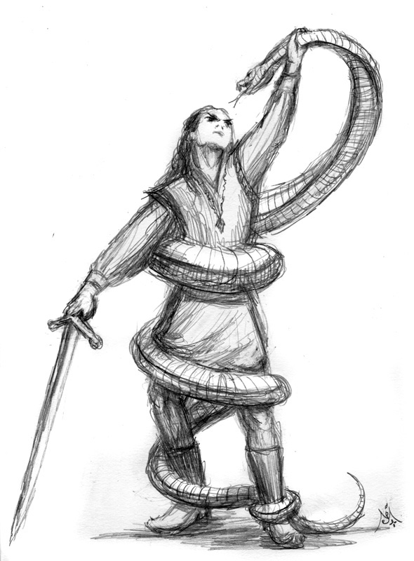

Book 4
The Silver Chair
Jeffrey L. Gerig

1 THE SILVER CHAIR pp. 1-66 (book chapters 1- 5)

1. How did Eustace and Jill get into Narnia? Was it their own words that brought them there (p. 19)?

2. Where did Eustace and Jill enter Narnia? Why enter here?

3. What happened on the cliff (p. 12)?

4. Jill found herself in an awkward position at the stream with the lion (p. 17). Why did Aslan make it tough for her to get water? What was he trying to do?

5. Why wouldn’t Aslan promise Jill that he would not eat her? What did he mean when he said, ‘I have swallowed up girls and boys, women and men, kings and emperors, cities and realms?’

6. Aslan not only made Jill put trust in him, but he also confronted her with her pride and foolishness (p. 18). The lion forgave her, but also said that her job would now be harder. Why?

7. Aslan’s charge to Jill was, with Eustace, to ‘seek the lost prince until either they had found him and brought him to his father’s house, or else died in the attempt, or gone back to their own world (p. 19).’ Which of these three do you think will happen? Why?
8. Aslan gave Jill four signs (pp. 19,20). What were they?
Sign #1 –
Sign #2 –
Sign #3 –
Sign #4 –

9. Eustace and Jill were to accomplish their task from Aslan by obeying the Four Signs. As Christians, we are called to discover God’s will in our lives, by obeying His Word.
*Why is it important not to forget God’s Word (pp. 20, 21)?

*When Jill said that she understood the instructions, Aslan said, ‘Child, perhaps you do not see quite as well as you think.’ Why did he say this (p. 20)? What does this tell us about God’s Word?

*When were Jill and Eustace to go over the signs (p. 21)? When is the best time for you to be in God’s Word? Why?

10. What did Aslan mean when he said, ‘…the Signs which you have learned here will not look at all as you expect them to look, when you meet them there (p. 21)’? How is this true when we take the truth we learn in God’s Word into our daily lives?

11. Why did Eustace and Jill miss the first sign (p. 38)? How long had it been, in Narnian years, since Eustace’s first visit?

12. When they saw all the food set before them in Cair Paravel, Eustace cheered up and said that it was ‘something like the greatest feast ever served (p. 40).” What might he be referring to?
13. Why was the king sad? Who was the queen, and how was she killed (p. 49)?

14. What message do you think the queen tried to deliver just before her death (p. 49)?

15. What happened to the prince (p. 50)? Why didn’t the green serpent kill him also? Who does this green serpent represent (p. 51)?

16. Why couldn’t Eustace go up to Trumpkin and explain things?

17. How would you describe a ‘Marshwiggle’ (p. 58)? How would you describe Puddleglum? Do you know anyone like him? Is it possible to change a person with this outlook?

18. Who do you think the owls represent in this story?

19. How good are you at receiving advice and constructive criticism from others? Why is it important to surround ourselves with wise people who can help us with our shortcomings?

THINGS TO REMEMBER:
1. The story of Prince Cor and Aravis and the horse, Bree, which was told to Eustace and Jill on their first night in Narnia (p. 40)
2. The story of Prince Cor and Aravis happened in Narnia and Calormen and the lands between, in the Golden Age when Peter was High King at Cair Paravel.
3. King Caspian had moved the throne from his uncle’s palace to Cair Paravel once again. They must have restored it.
2 THE SILVER CHAIR pp. 67-135 (book chapters 6-10)
1. Who was the Lady, the Queen of the Green Kirtle (p. 75)? Who is the silent black knight? Why would she show up in the land of the giants?

2. Why did the witch send Eustace, Jill, and Puddleglum to the Gentle Giants for the Autumn Feast (p. 76)? Do you think she knows what they are up to (sent by Aslan on a mission to free the prince)?

3. Why did Jill forget to recite the Signs (pp. 79,80)? How does this relate to our lives and God’s Word?

4. Like the disciple, Peter walking on water (see Matthew 14:25-33), why do we sometimes turn our eyes away from Christ and focus on ourselves and our circumstances?

5. Why did Eustace and Jill miss the second and third Signs (p. 102)? Whose fault was that?

6. How did the Witch tempt the children to turn from following the Signs (p. 103)?

7. What important things in our lives will Satan try to distract us from doing? Is he doing a good job of distracting Christians today? How successfully does he distract you from what God wants you to do?

8. After missing Signs two and three, Jill tried to rationalize, saying that possibly Aslan put the letters there after they had passed by. She didn’t want to believe they had messed up again (p. 103). What are ways we try to rationalize our failures?

9. What does ‘UNDER ME’ mean? What did it mean a long time ago (p. 133)?

10. In the last book, we got a glimpse of what heaven would be like in the Narnian world. What are we getting a glimpse of in this book? Describe this place.

11. Why was the idea of eating a stag so horrible to the Marshwiggle (pp. 111,112)? Describe the feelings each one felt:
Jill –
Eustace –
Puddleglum –

12. By eating Stag, do you think that they brought on themselves the curse of Aslan, like Puddleglum thought? Are we held accountable for the sins we commit in ignorance?

13. What was the phrase they repeated over and over in the Underworld? Why did they keep saying it (p. 122)?

14. What did all the Earthmen have in common (p. 123)? What is the picture in your mind when you think of Hell?

15. Who is the old man sleeping below the earth (p. 127)? Why is he there, and why is he sleeping?

16. If the silent black knight is Prince Rilian, what has happened to him, that he now swears such allegiance to the Queen?

3 THE SILVER CHAIR pp. 136-end (book chapters 11-16)
1. How does Prince Rilian understand the magical spell over him? What is really the enchantment (p. 137)?

2. Why does the Queen (Witch) need the prince? Why can’t she simply take over Narnia by herself?

3. On p. 138, Prince Rilian states, ‘Is it not the most comical and ridiculous thing in the world to think of them all going about their business and never dreaming that under their peaceful fields and floors, only a fathom down, there is a great army ready to break out upon them like a fountain!” How is this similar to the way Satan and his demons work?

4. Do you ever think that you may have been deceived by Satan at times and never even realized it? Can you think of a specific instance? How does this realization make you feel?

5. When the Queen took the Prince out on trips in the overworld, what was the real reason the Prince went fully armed, with his visor down? What did the Prince think was the reason (p. 139)?

6. Why was the Queen usually the only one with the Prince during his ravings (p. 140)? What did the Prince think was the reason?

7. Why did Eustace, Jill and Puddleglum have so much difficulty in following the fourth Sign (p. 146)? Is it ever hard to follow God’s instructions? Does it ever seem like He’s asking too much from us, or even has made a mistake?

8. Why does the Witch spend so much time trying to convince them that their world is just a copy of her ‘real’ world (pp. 155,156)? How does Satan twist things around, getting us to believe his counterfeits are better than God’s originals?

9. How do they escape the Queen’s spell (p. 158)? Similarly, how are we able to overcome and escape Satan’s schemes?

10. Puddleglum says, ‘She’s the sort that wouldn’t so much mind dying herself if she knew that the chap who killed her was going to be burned, or buried, or drowned five minutes later (p. 166). ‘ How does this accurately describe Satan’s character?

11. Who was Golg (p. 176)?

12. Describe the Land of Bism (p. 177). What voice was heard from there and what did it say (p. 183)?

13. How is this underworld like Hell? How is it different?
Similarities Differences

14. Jill was afraid of meeting Aslan after their mission was accomplished (p. 210). Aslan said to her, ‘Think of that no more. I will not always be scolding.’ What does this say about God?

15. If Rilian had stayed with the Witch, he would have become a King over a land that was already rightfully his to inherit. Satan likes to promise us things that by our rights as God’s children, we will inherit anyway. What are some of the lies Satan gets us to believe?

16. Why wasn’t Caspian a ghost in Aslan’s land, but would have been had he showed up in Narnia (p. 213)?

17. Why did Caspian get younger in Aslan’s land, yet have no particular age (p. 212)? What age do you picture yourself being in heaven, once you are there?

18. Why did Eustace put a thorn into Aslan’s paw (p. 212)?

19. Why did Eustace and Jill have to go back to their own world? What does this tell you about salvation?

20. Why did Aslan let Caspian enter our world for a short time? What did Caspian do?

Leader’s Guide
The questions in this guide are not meant to limit your group discussion, but rather to bring out new thoughts, as well as open a door of new questions for your group. Below are possible suggested answers for some of the more difficult questions in this study guide.
Study 1 The Silver Chair pp. 1 - 66
Question 4: Aslan wanted Jill to exercise faith in him, not knowing what the consequences would be. It is only through the lion that we can get the living water to live by. There is no other stream.
Question 5: Aslan would make no deals with Jill. This is just how we must approach God. He makes us no deals that when we accept Christ that things will all work out great. We must first trust, and leave the results to God. God has swallowed up nations in judgement, but never those who are searching for Him, or seeking to do His will.
Question 8: The four signs were...
1. You will meet an old and dear friend the moment you set foot in Narnia.
2. Go north out of Narnia until you come to the ruined city of the ancient giants.
3. As you travel, you will find writing on a stone in that ruined city, and you must do what it tells you.
4. You will know the lost Prince because he will be the first person you meet who tells you to do something in the name of Aslan.
Question 12: Eustace had once before shared in a mighty feast at the beginning of the end of the world. This must have been something like that great feast.
Question 15: At first the prince thought of nothing else but revenge for his queen mother. Eventually he became intrigued by the witch herself, and then the very person he most wanted dead, he now followed. He became so preoccupied with her, that he lost touch with reality. This green serpent also represents Satan. The queen needed the prince because of the way Aslan had set up this world. There was to always be a human on the throne of Narnia. This was her chance to rule.
Question 18: the owls probably represent wise people with the gift of discernment. They would be other Christians who help direct us in carrying out God's will for our lives. The owls help direct Eustace and Jill.

Study 2 The Silver Chair pp. 67 -135
Question 3: Once Jill and Eustace began thinking of good things for themselves, they have a hard time concentrating on God's will. They took their eyes off of Aslan and the Signs, and focused them on their own selfish desires. This is often how Satan gets us to waste time and be ineffective for the cause of Christ.
Question 8: When they missed the signs, all of them wanted to pass the buck, but all were somewhat to blame. We too try to pass the buck or rationalize our mistakes. Often we say things like, “There is someone else better than me who can do it”, Or “no one told me to do it specifically”, or even “the instructions weren't clear enough”.
Question 9: These were the words Aslan was using to tell the children where to go. Long ago the words meant “Though under earth and throneless now I be, yet, while I lived, all earth was under me.” Aslan made sure just the right words were showing to lead the children on their way.
Question 12: their eating of the Stag was a sin, but one committed in ignorance. They did not know what they were doing. Now if they had kept on eating, they would have been bringing on Aslan’s judgement. We sin many times in ignorance, but if we have Christ in our lives, these sins are forgiven, even without our knowing of them. If Christ is not in our lives, we will face the full judgement of God, even for sins we do not know we have committed.
Study 3 The Silver Chair pp. 136 – end
Question 5: The real reason that the witch took the prince with him is that she did not trust leaving him alone. She did not want anything to go wrong. The prince thought it was too accustom his eyes to the light. Notice how ridiculous the prince’s reasoning has become.
Question 7: The sign was nothing like what they expected. Aslan had warned them that it would not be what they expected. Notice that to try and figure out God's will can only get you confused at times. It wasn't until Puddleglum remembered that Aslan only told them to obey the signs, regardless of what happened to them. Only then did they finally obey.
Question 12: A voice from below says quick, quick, to the cliffs, to the cliffs. We aren't sure who said this, but it must have been, from Aslan's orders to hurry the children all along.
Question 17: Heaven has no ages. There will be no decaying in heaven, so there is no aging process. Your body will not grow old, but no one knows exactly what the age will be.

