STUDY GUIDE
for the
Chronicles of Narnia by C.S. Lewis

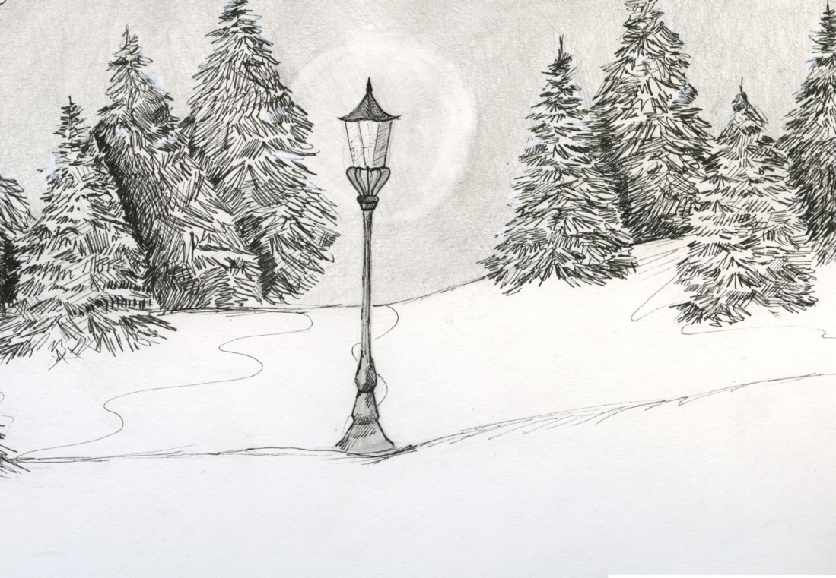

Book 1

The Lion, the Witch, and the Wardrobe

Jeffrey L. Gerig

1 – THE LION, THE WITCH, and the WARDROBE pp. 1-50
1. Describe the character of each person. Be specific.
Peter
Susan
Edmund
Lucy

2. Why do you think that it was Lucy who discovered Narnia? (see Matthew 19:13-15)

3. What is Narnia like? What did it used to be like before the White Witch took power? Why do you think she made it always winter, but never Christmas?

4. Who does the Witch represent from our world? How are they similar?

5. Why do you think that the time in Narnia is different from the time in our world?

6. How did the Witch entice and manipulate Edmund? (see James 1:13-15) What does this tell us about who is to blame when we fall into temptation?

7. Once Edmund had given ground to the Witch, why was it easier to give in the second time?

8. In what areas of your life does the devil tempt you and take advantage of you? How can you resist him and not give in to his temptations?

9. Why did Edmund lie about having been in Narnia? Didn’t he want to get back (to get more Turkish Delight)? Do you know anyone so proud that they would rather give up something good than be shown up by someone else?

10. Peter and Susan talk to the professor about Lucy and her unbelievable story. The professor says that there can be only three possibilities (p. 45). What are they?
1.
2.
3.
They finally conclude Lucy must be telling the truth, based on her character. How would you respond if someone tried to tell you about a place like Narnia? What if that person’s character was much like Lucy’s?

11. What type of character do you demonstrate? Are you like Lucy, reliable and trustworthy? Or like Edmund, mean and self-serving?

12. In witnessing to a non-believer, your story of Christ dying for the sins of the world may sound as far-fetched as telling someone about a secret place such as Narnia. What role does ‘character’ play in sharing the gospel with others?

2 THE LION, THE WITCH, and the WARDROBE pp. 51-118
1. How did Edmund’s thinking about people get so confused? Why did he distrust just about anyone who could have helped him, such as the robin (p. 58), the fauns (p. 59) or the beavers (p. 63)?

2. Who does the lion, Aslan represent from our world? How are they similar?

3. What different thoughts popped into the the kids’ minds when they heard the name ‘Aslan?’ Why, when they didn’t even know him yet (pp. 64,65)?
Edmund –
Peter –
Susan –
Lucy –

4. Why do you think Edmund betrayed his own brother and sisters (pp. 33, 85)?
a. he was under a curse from the Turkish Delight
b. he wanted to get more Turkish Delight
c. he wanted to become a prince, and later a king
d. he wanted to get even with the others, especially Peter
e. all of the above

5. If Edmund was really under a magical curse from the Turkish Delight, should he really be blamed for his actions (p. 33)? What does the Turkish Delight symbolize in this story?

6. Why should we be held accountable for sin in our lives, when we are born with a sin nature? We can’t help but sin, so why should we be punished for it?

7. There were a few times when Edmund almost decided not to go to the witch, but turn back to join the others. What kept him from changing his mind? What keeps us from turning away from doing things we know are wrong?

8. Why is it that the kids can only save Edmund by finding Aslan, and not by going to rescue him at the home of the White Witch? What does this tell us about sin (p. 81)?

9. Whose role does Father Christmas represent (pp. 102,103)? Why does he bring presents? What kind of presents are they?

10. Why did the four children need to get to the four thrones in order for the spell of the Witch to be broken? Why can’t Aslan just strike the White Witch dead and do away with her spell?

11. Why did the curse begin to break early, even before the four children actually reigned on the four thrones?

3 THE LION, THE WITCH, and the WARDROBE pp. 119-end
1. What does the Stone Table represent? What is written on it?

2. Lucy just wished that Edmund’s sin could be taken away and forgotten. Aslan said that it would, but that it would be much harder than she thought (p. 124). Why did he say that? (see Romans 6:23)

3. Do you think that there is any significance in Peter’s name and his being the oldest and in charge (p. 126)? Why does Peter accept part of the blame for Edmund’s betrayal? Why did Aslan say nothing to him at that time (p. 124)?

4. Why did the White Witch have a claim on the life of Edmund based on the Stone Table and the magic that the Emperor put into Narnia at the very beginning of time (pp. 138,139)? What is this ‘deep magic?’

5. What happened to the Stone Table when Aslan awoke and came back to life? How does this relate to the time when Jesus Christ rose from the dead and the temple curtain was torn in two? (see Luke 23:44-46) What happened to the Law of Moses at that time?

6. After Edmund had met with Aslan, why was there no need for the others to talk to him about the past (pp. 135,136)? What do you think Aslan said to Edmund in this unforgettable conversation?

7. Why didn’t Susan think they should tell Edmund what Aslan had done for him (p. 177)?

8. How is Edmund and his sin much like you and me, when we willfully sin and disobey? Is there sin in your life which needs to be confessed and forgiven? (see I John 1:9) Explain, how does Jesus Christ forgive your sins?

Leader’s Guide
The questions in this guide are not meant to limit your group discussion, but rather to bring out new thoughts, as well as open a door of new questions for your group. Below are possible suggested answers for some of the more difficult questions in this study guide.
Study 1 The Lion, the Witch, and the Wardrobe pp. 1 – 50
Question 2: Lucy was probably the one who discovered Narnia because of her child like faith, that made it easier for her to believe. She hadn't learned to distrust people yet, or be cynical, unlike her Brother Edmund.
Question 5: It seems reasonable that since this was a totally different world, that it would have a time all its own. God is not bound by the time in any world, so it would not be any big thing for Him.
Question 6: The witch manipulated Edmund by getting him to think that the good people were really bad and the bad people were really good. Edmund ended up trusting nobody. She also appeals to his likes, which is definitely Turkish delight. Once she had broken his will, she then used force and fear to get him to do what she wanted. Satan is just like that as well. He preys on our sin nature, and our evil desires, which we try to control. He questions our willpower. Satan does all this enticing, but he cannot get us to sin. We always have a choice, so we will always be to blame, when we give in to Satan.
Question 8: Satan always tries to find our weak spot in which to tempt us. There are many ways in which we can resist him. Reading God's word and prayer are the two most effective ways to fight off temptation. Others include, talking about it to a friend, singing Christians songs, or finding something else constructive to do.
Question 10: The only three options to explain Lucy’s story would be 1) she is lying to them, 2) she is going crazy or 3) she is telling the truth and there really is a Narnia.
Study 2 The Lion, the Witch, and the Wardrobe pp 51-118
Question 1: Once Edmund had put an element of trust in the witch, it began to confuse his thinking. If she were telling the truth, then the people who he would have considered good would really be bad. He is no longer sure who to believe, the robin, the fauns, the beavers, or the witch.
Question 3: The Bible tells us that we all have some sort of idea of God written upon our hearts. We all have an urge to fill the empty spiritual void in our lives. To Edmund, the name of Aslan brought “a sensation of mysterious horror”, which probably was because he had aligned himself with the witch. Peter felt “brave and adventurous”, while Susan felt as if “some delicious smell or some daylight strain of music had floated over her”. Lucy got “the feeling you have when you wake up in the morning and realize that it is the beginning of holidays or the beginning of summer”. Her faith and innocence drew her closer to Aslan than the others.
Question 5 & 6: We are still accountable for our sin, because we are to blame for our sin nature. Adam was our representative of the human race, when he sinned. When he sinned, it was as though we all sinned. We must also remember, that even though we have a sin nature which draws us toward sin, we also have a free will which allows us to choose the right way. If the Holy Spirit lives in us as Christians, He will also help us resist sin.
Question 10: Not much time should be spent trying to find out why Father Christmas was in this story. Most probably it was because C.S. Lewis liked the idea of tying the two Christmas stories together. But without drawing too much parallel, could Father Christmas possibly be a type of the Holy Spirit, equipping them with gifts for fighting the witch’s advances. The gifts could be references to the armor of the Lord, or possibly the gifts of the Spirit, which are to be used for building up the family of believers. Whatever opinion you might lean toward is probably the correct one.
Question 11: Aslan always wanted to use humans to carry out his will, whenever possible. He could have zapped the witch, but instead he chose to work through humans. This leads to an important thought for those in your group. Is God right now waiting for you to do something, which He could easily do Himself, but would rather you do?
Study 3 The Lion, the Witch & the Wardrobe pp. 119 - end
Question 1: The Stone Table represents the covenant of the Old Testament, with the Law and all its regulations. Under the law of this table, anyone who breaks it must be put to death. That is why a death must occur to cover Edmund’s sin of betrayal. Aslan gave up his life in place of Edmund’s on the Stone Table, but he could not stay dead, because he himself was without sin.
Question 6: There was no need for the others to bring up Edmund’s sin because it was forgiven through the dying of Aslan. It was in the past, and was not to be brought up. The same is true of our sin. Once it is confessed and forgiven, we are not to dwell on it, or go back to it.

