STUDY GUIDE
for the
Chronicles of Narnia by C.S. Lewis

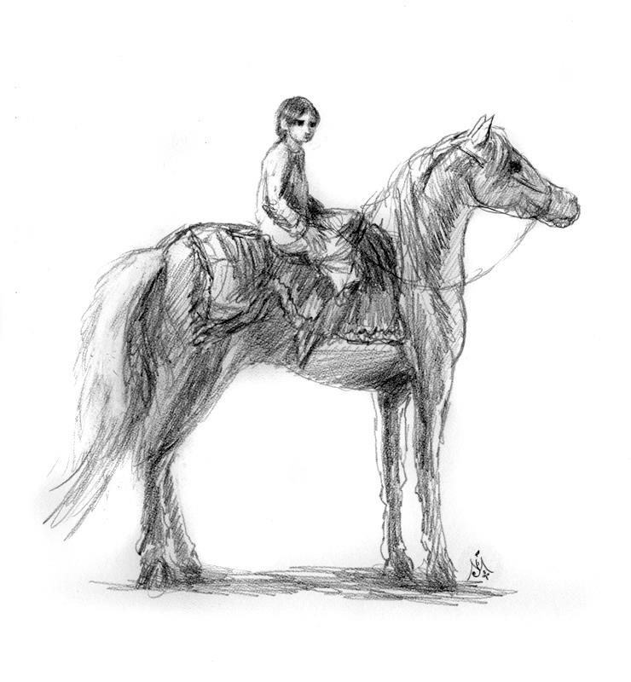

Book 5
The Horse and His Boy

Jeffrey L. Gerig

1 The Horse and His Boy pp. 1-62 (chapters 1 - 5)
1. When and where did this story take place? (p.1)

2. Retell Shasta’s story of how he came to find himself in Calormene, living with a fisherman. (p. 5)

3. Describe each of the characters, based on your present knowledge of them.
Arsheesh -
Shasta
The Tarkaan from the south, known as Anradin -
The Tisroc -
Bree -
Hwin
Aravis -
Tash
Zardeenah -
Aravis’ Father, the Lord of the province, Calavar -

4. If you were standing in the middle of Narnia, based on your readings of the Chronicles of Narnia, what would be to the…
East?
West?
North?
South?
5. If Narnians are really the people favored by Aslan, why do the Calormenes call them “the accursed, but beautiful barbarians who inhabit the north”? (p.5)

6. Why do people today still evaluate others based on appearance, race, or culture? What is God's response to prejudice? (see Numbers 15:15)

7. Do you think that it was real Lions chasing them, or maybe just what they thought were lions, or possibly even Aslan himself? (p. 25) Why did they think there were two lions, when it ended up being only one?

8. If the lions were really Aslan, why would he be chasing them and roaring at them?

9. Can you give an example of how God uses circumstances to get what He wants accomplished?

10. A major theme up to this point has been PRIDE. How did the following people show evidence of pride in their lives?
The Calormenes -
Shasta -
Bree -
Aravis -
The Tarkaans –
“For in Tashbaan there is only one traffic regulation, which is that everyone who is less important has to get out of the way for everyone who is more important, unless you want a cut from a whip or a punch from the butt end of us spear.” (p. 53)

11. Is having pride always wrong? Is it wrong to take pride in the work that you do? Is pride ever right?

12. Hwin is the contrast to the others in this story. She demonstrates true humility. (p.45) Because of her humility, she is often put down, and taken for granted. How can a Christian demonstrate true humility, without being walked over by others?

13. How do things get messed up in Tashbaan?

14. Who is Shasta mistaken for?

15. Why are Edmund and Susan in Tashbaan? Give at least three reasons why Susan should not marry Prince Rabadash.
1.
2.
3.

16. What do the Calormene nation represent? How about the land of Narnia? Why don't they get along well together?

17. Remember that Aravis is not from Narnia and is not yet a believer in Aslan. She still says, “Long live the Tisroc” and still acts like a Calormene. She does not know any different at this point. Do you think Aslan should reveal himself to her all at once or by a little at a time? Why?

2 The Horse and His Boy pp. 63-146 chapters 6 to 10
1. What is the size of Narnia compared to Calormen? What is the significance of this? (p. 65)

2. There is a secret way to cross the desert from Calormen to Narnia. What is it? (p. 66)

3. What about this cat at the tomb of the ancients? (p. 82-86) Who was this cat and what did he do?
a.
b.
c.
d.

4. Why did Aslan appear as a cat this time, and not as himself, or as a lion?

5. Notice that Susan mentioned that the moles were planting an orchard for them at Cair Paravel. (p. 67) What story does this information tie in with?

6. Describe Lasaraleen. Do you know anyone like her?

7. Why wasn't the Tisroc in such a hurry to attack Narnia? (p. 107-109) What does the prince think is the real reason? Is the Tisroc a believer in Aslan?

8. What is Prince Rabadash’s plan for attacking Narnia? (p.110)

9. Once the runaways had crossed the desert, why was it so hard to get motivated to go on the rest of the way to Narnia? Why did Bree want to rest and snack, instead of getting to Archenland? (p.131) How does this apply to the Christian's life?

10. After they had crossed the river, they are attacked by a lion again? Is this one Aslan? Why is he chasing them? Why does he claw Aravis? (p.137-139)

11. Why didn’t Aslan just make them wake up from their nap? Why did he wait until it was almost too late, and then scare them to death, by chasing them to the hermit’s house?

12. Aravis thought she was “lucky” not to have been scratched as badly as she first bought. The hermit said, “I have now lived a hundred and nine winters in this world and have never yet met any such thing as luck”. (p.143) What does he mean by this?

13. What are the results of the lion’s attack on each person?
Shasta -
Aravis -
Bree -
Hwin -
14. How did the hermit know all the facts about everything before he was told anything? (p. 140)

15. Why was Shasta the only one sent to warn King Lune? (p. 141)

16. Why did Bree want to go back to Tashbaan? (p. 145) How is Aslan breaking Bree’s attitude of pride?

17. Aravis’ words to Bree were, “it is better to stay and say we're sorry, then go back to Calormen.” How does this statement relate to human pride, forgiveness of sins, and salvation?

3 The Horse and His Boy pp. 147- end (chapters 11 to the end)
1.. Why did Shasta feel that he is the most unfortunate and unlucky person who ever lived? (p. 155,157) Was it really true? Why or why not?

2. Why do difficult situations often cause us to lose our perspective on things? What can a person do to regain his perspective, quit feeling sorry for himself, and see things clearly again?

3. We finally find out for certain that the lion was Aslan all the time. (p.158) What all did Aslan do in this story?

-
-
-
-
-
-

4. Why would Aslan not tell Shasta why he had clawed Aravis? (p.159, also p. 194) Why did he say, “I tell no-one any story but their own?”

5. When Shasta arrived in Narnia and told his story, no one really wanted to send the news to Cair Paravel. (p. 164) Why?

When things go well in our Christian lives, we too tend to get a little careless. We take our faith for granted. What are some things we can do to keep our guard up against Satan's attacks, especially when things are going well?

6. Why did Lucy ride to the wars, but Susan did not? Isn't Susan to blame for all this mess? Why didn't she try to make things right? (p.176)

7. How could the hermit tell the future? (p.180) what role did he play for Aslan? What would we call this type of person in the Bible?

8. Bree, for a second time, was worried about going back to Narnia. (p.180) The first time it had to do with his lack of courage. What was his problem this second time?

9. Bree believed in Aslan, but in a figurative sense. He didn’t believe that Aslan was a real lion. (p.191) Today many believe in God, but have the wrong impression of Him. What misconceptions do people have about God?

10. Who is Shasta really? (p.195) How did he come to end up in Calormen?

11. Pride was a major theme in this book. How do all the characters show that they are a little humbler by the end of the book? (p. 204)
Aravis -
Cor -
Bree and Hwin -
Rabadash – (p. 213)

12. What traitor is Edmund talking about when he says, “… even a traitor may mend. I have known one that did.” Why does he not let himself forget that experience?

13. Rabadash was the last prideful person, and would not give in, even when turned into a donkey. Why would he not change?

14. How does everyone in the story end up? (p.215-216)
Shasta (Prince Cor) -
Prince Corin -
Aravis, the Tarkheena -
Bree and Hwin -
Rabadash –

Leader’s Guide
The questions in this guide are not meant to limit your group discussion, but rather to bring out new thoughts, as well as open a door of new questions for your group. Below are possible suggested answers for some of the more difficult questions in this study guide.

Study 1 The Horse and His Boy pp. 1 - 63
Question 4: To the east would be all those lands visited by Caspian, and ultimately the end of the world, and Aslan’s country. To the West we don't know yet. To the North are the giants and the witch’s underground home and to the South is Calormene.
Question 8: If the lions were really one lion, Aslan, his purpose would probably be to get the two parties together, so that they could work together toward the same goal. Aslan was in charge of the situation, even though they were unaware of his working. That is how it is with God also. He works many times behind the scenes and we are not even aware of it.
Question 15: There are more than three reasons why Susan should not marry the Prince, but three might be that he is not a believer in Aslan, he is selfish, and he is not the same at home, then when he was courting her in Narnia.
Question 16: the Calormene nation represents non-Christian, worldly lifestyle, which is characterized by pride, and selfish living. The Narnian lifestyle is more Christian, and thinks of others.
Study 2 The Horse and His Boy pp. 63-146
Question 2: The secret way is to first go to the Tombs of the Ancients and travel northwest so that the double peak of Mount Pire is always straight ahead. After this travel the bit more than a day, and one will come up on a valley, and deep down inside it, there is a stream and grass.
Question 3: This cat lead Shasta through the tombs to the other side. He protected him from the jackals. He comforted him at a time when he was all alone and scared. And he scratched Shasta when he mentioned what he had done to a stray cat one time. This cat must be none other than Aslan himself.
Question 5: See Prince Caspian
Question 6: Lasaraleen is a very shallow person who is really more concerned with her dresses, then with the trouble Aravis is in. It isn’t until she is faced with a life or death situation, that she panics and falls apart. She does help Aravis though.
Question 10: Aslan is forced to chase them since they overslept, and had wasted much time. Now they needed to run as fast as they never had before. It was to accomplish his will. Aravis is clawed for her treatment of her attendant, who she had left to get into trouble for her escape. This is her punishment from Aslan. Aravis up to this point had never shown any remorse. (p. 40)
Study 3 The Horse and His Boy pp.147 - end
Question 2: Aslan was the lion who forced Shasta and Aravis together. He was the cat who comforted him among the Tombs of the Ancients. He was the lion who drove the jackals away from him in the night. He gave the horses the extra strength to get to the Hermit’s house to warn King Lune. He was the one who guarded him through the pass into Narnia. And he was the one who pushed the boat to the shore to be found by Arsheesh, the fishermen, when Shasta was but a little baby.
Question 5: Since the downfall of the white witch, the animals had gotten a bit careless. They weren’t ready for such an attack and weren’t sure quite what to do. Luckily a few were still cautious to the danger. As Christians we too should not get careless with our faith. Satan is constantly on the attack.
Question 9: Some make God out to be softer than He really is, hoping He will overlook our faults and sins. Others make Him out to be meaner than He is, thinking of Him as a Judge who is out to spoil all our fun. Others think of him as they do their earthly fathers. Many do not think He is powerful enough to handle their problems. Others think He is too big to be concerned with our troubles.
Question 10: Shasta is really Prince Cor, the crown prince of Archenland. The Lord Bar, King Lune’s chancellor had been embezzling money and was afraid he would be caught. When Prince Cor was born, a prophet said that he would save Archenland from some evil. The Lord Bar thought it was him who would be caught. He kidnapped the child and fled to Calormen. He had secretly been selling secrets to them as a spy. His ship was overtaken, but the child and a servant escaped. The servant died, but Aslan pushed the boat to Arsheesh the fisherman.

