STUDY GUIDE
for the
Chronicles of Narnia by C.S. Lewis

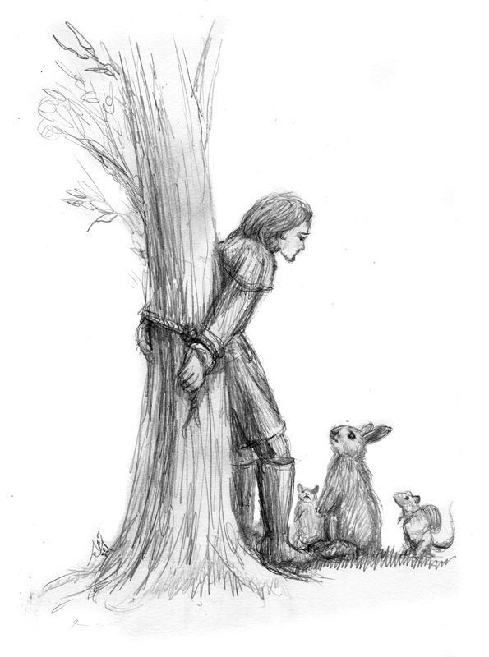
Book 7
The Last Battle
Jeffrey L. Gerig

1 THE LAST BATTLE pp. 1-67
1. Where and when does this story began? (p. 1)

2. Describe the following characters:
Shift –
Puzzle –

3. Was Puzzle to blame for the misfortunes which came his way? What was his real problem? (p. 7) Do you know anyone like Puzzle? What makes them that way?

4. In what ways did Shift distort the truth? (pp. 10,11)

5. Describe the following characters:
King Tirian of Narnia –
Jewel, the Unicorn -
Roonwit -

6. What was Roonwit’s two-part message to King Tirian? (p.15)

7. Why do you think that Aslan had not been in Narnia for so many years? Why does God seem to take a spectator view in our lives at times?
8. What does the phrase, “Aslan is not a tame lion” mean? (pp. 16,20,24) How did King Tirian take its meaning? In what ways is our God not tame?

9. King Tirian did a very foolish thing. What was it? (p.20) (гл. 2) “Why did much evil come of their rashness in the end?”

10. Why did they go back to the scene of the crime and turn themselves in? (p.24) Would you have gone back? Why or why not?

11. How would you feel if it turned out that our God had a dark side, and decided to live only for himself from now on? (p.24)

12. The ape said that Tash was only another name for Aslan. What was the ape trying to do by saying this? Does he really believe in Tash or Aslan? Does the Calormene leader believe in Tash? (p.31)

13. Why do you think Ginger, the cat was not disturbed about this new information that Tash and Aslan were the same? (p.32)

14. When tied to the tree, what made King Tirian feel better and find hope? (p.41) How do you feel about the old Bible stories? Do they seem real to you, or do you feel they are too far removed to be true or of any value to your life?

15. Do you think something like the people crossing the Red Sea, or Jonah and the great fish could happen today? Why or why not?

16. Describe King Tirian’s dream? Or was it a dream? (pp.42-44)

17. What did the King see? Who was missing from the table? Why do you think she was missing? (p.42)

18. Why were the two youngest of the 7 sent to help King Tirian? (p.50) Why not King Peter?

19. How did Eustace and Jill get into Narnia? (pp.50,51)

20. What did Jill discover just before the end of this section? (p. 65)

2 THE LAST BATTLE pp.68-124
1. What do you think about the attitude of the dwarfs? (pp. 71-73) Why wouldn’t they fight for freeing Narnia? Why did they kill the fighting horses of Narnia? (See also 104-111)

2. Do you know someone like this, who got burned once with Christianity, maybe in a youth group or a church, and now they want nothing to do with God? Is there anything a person could do for them?

3. Describe the following characters:
Griffle -
Poggin –

4. Rishda, the Calormene captain, and Ginger, the cat take authority away from the ape, Shift. What were they both in it for? (p.77)

5. Ginger, the cat is first mentioned on page 32. He seemed to have it all figured out. He was sure there was no such thing Aslan or Tash. What became of Ginger? (p. 108)

6. Is there really a Tash? What does he look like? (pp.81,82) Who does Tash represent? Why are there people today who do not believe in Satan?

7. The ape Shift first told the people that Tash and Aslan were the same. (p.31) At that time a little lamb spoke up, “Please, I can’t understand. What have we to do with the Calormenes? We belong to Aslan. They belong to Tash…” The ape spit on him and called him names. Jewel tells us later (p.84), that the lamb must have been put in the stable for execution, for he was in there with him. Who might this little lamb have been that demands so much attention?

8. While Jill was talking with Jewel about the golden years of Narnia, she said that she wished that Narnia could continue millions of millions of years. (p.89) Why? Would you wish that this world would last for millions and millions of years?

9. Farsight, the eagle, brings bad news to the company. (p. 91) What was this bad news?

10. Eustace and Jill got to talking about death. (p.96) What would have happened to them if they had died in Narnia? What about Eustace’s words about the jerk that brought them into Narnia being like the beginning of a railway accident. Did Aslan save them, to have them die in Narnia? What about the rest?

11. Who was Emeth? What happened to him? Why was he not killed? (p.112) Who was the person killed and thrown out of the stable?

12. Who actually do you think is in the stable? (p.115)

13. How are the events in this book similar to what will happen at the end of our world, as recorded in Matthew 24:4-14; 26-35?

3 THE LAST BATTLE pp.125-end
1. Who was thrown into the stable?

2. Who had been in the stable all the time?

3. Why did Aslan say that Rishda Tarkaan was Tash’s lawful prey? (pp.132,133) Is that also true of non-believers today? Are they Satan’s lawful prey?

4. When king Tirian regained his senses, who was standing before him? How did they come to enter Narnia? (pp.137-138)

5. What had become of Queen Susan? (pp.134,135) Why do some in our world turn their back on God’s truth?

6. How would you describe the stable? (p.140)

7. What was Lucy referring to when she said, “In our world too, a stable once had something inside it bigger than our whole world”? (p.141) Explain.

8. Can you remember another time when Aslan put up a door frame in the middle of space, which led into another dimension? (See Prince Caspian p. 211)
9. Why could no one, including Aslan himself help the dwarfs to understand? (p.148)

10. Aslan opened the stable door and the end of the world began. Describe how the present Narnia came to be no more?

11. Why did animals and people come, whom they thought were dead, like the bear, the boar, Poggin the dwarf, Roonwit the centaur, and Jewel the unicorn? Why was a dwarf who had shot one of the Narnian horses also allowed to gather behind Aslan? (p. 154)

12. Why was Emeth not destroyed by Tash, while the Tarkaan was not as fortunate? (pp.161,162) Does this mean that as long as you are a nice person, God will let you into heaven?

13. Why were they to go further in, and further up? Describe the new Narnia. (pp. 168,169)

14. Why were Digory, Polly, Peter, Lucy, Edmund, Jill, and Eustace allowed to enter into Aslan’s land through Narnia? Before Aslan had told them they must go through their own world. (p.183)

15. Whom do they see on another run traveling up to the middle, Aslan’s country?

16. How does this new Narnia compare with what our new heavens and new earth will be like? (See Revelation 21)

17. What do you look most forward to about getting to heaven? Whom do you long to see the most?

Reflection:
After reading all these books, what are your feelings regarding them? What did they do for your Christian faith?

Which book was your favorite? Why?

Leader’s Guide
The questions in this guide are not meant to limit your group discussion, but rather to bring out new thoughts, as well as open a door of new questions for your group. Below are possible suggested answers for some of the more difficult questions in this study guide.
Lesson 1 The Last Battle pp. 1 – 67
Question 4: Shift, to get his own way, convinced puzzle that Aslan sent the lion-skin for them to use. (p.10) He also said the thunderclap was a sign from Aslan that they were doing his will. (p.11)
Question 6: His message was: 1) Aslan had not come into Narnia, and 2) some great evil is to befall Narnia.
Question 7: As we will learn later, Aslan has been in Narnia, but no one realized it. Possibly he did not make himself known because no one ever called on him for help. But even though he was not seen, he was in control.
Question 17: The King saw in his vision a table with seven people present around it. Professor Digory Kirke, Aunt Polly, King Peter, King Edmund, Queen Lucy, Eustace Scrubb, and Jill Pole were there. Susan is absent from the group. She was not interested in the things of Narnia anymore.
Question 18: Knowing there was trouble, Peter and Edmund had tried to dig up the rings. They were waiting for the professor, Polly, Lucy, Jill and Eustace at a train station in London. But after a sudden jerk, Eustace and Jill found themselves in Narnia. They didn’t need the rings after all. Aslan must have called them, or the King’s calling actually worked.
Lesson 2 The Last Battle pp.68 – 124
Question 1: Since the counterfeit Aslan, the dwarfs lost hope in the real Aslan. They decided to take care of things themselves, because at least they could trust themselves. Since they felt they might get tricked into something, they decided not to trust anyone.
Question 6: Tash does exit. He has the head of a bird, but the body of a man. He looks as though he would be a cruel bird of prey. He has four arms, with long, pointed claws. All around him a appeared darkness, and there was a smell of death on him. He represents Satan and his demonic world. Many in our world today do not recognize that Satan exists, and it gets them into big trouble.
Question 7: This little lamb might just be Aslan. There is little belief in him, so he appears yet small, but he is present in those tough times.
Question 8: Jill overlooks all the present trials and hard times. Jewel also exaggerates a bit in saying that Narnia has had thousands and thousands of peaceful years. When we are in tough circumstances, the past may look very good, but we must not live our lives in it. Our hope is in our next life, Aslan’s country.
Question 11: Emeth was a Calormene soldier who wanted to see Tash face to face. He went into the stable, but did not come out. He seemed very sincere in wanting to find out the truth, and possibly because he was walking in the light that he thought was right, he was spared. And this point in the story, it could also be that since he was a believer in Tash, Tash let him live.
Lesson 3 The Last Battle pp. 125 – end
Question 1: Ginger the cat, Shift the ape, Emeth the Calormene, Eustace, 11 bound dwarfs, Jill, the Tarkaan, and King Tirian and were thrown into the stable.
Question 4: The seven Kings and Queens of Narnia: Digory Kirke, Polly, Peter, Edmund, Lucy, Eustace and Jill. Here had been a terrible train wreck, which killed all of them, including Peter and Edward at the platform, and also their parents, Mr. and Mrs. Pevensie, who were also on the train. They are technically not in Narnia, but in the new Narnia. One actually had to be dead to be there, unless one entered through the stable door.
Question 6: “It seems then, that this Stable seen from within and the Stable seen from without are two different places”, said Tirian. “It’s inside is bigger than its outside”, added Digory. Heaven and earth in this world appear to be in the same place, but in a different dimension. Possibly part of heaven we’ll be right here on earth also.
Question 10:
1. Aslan calls forth Father Time from the Northern Moors.
2. The stars began to be called home by Aslan, first by a few, and then by the millions.
3. All types of people entered through the stable door: talking beasts, dwarfs, satyrs, fauns, giants, Calormenes, men from Archenland, Monopods, and strange beings from the remote islands.
4. Some passed on Aslan’s left into a dark shadow, and others gathered behind him on his right. This was the Great Judgment.
5. Dragons and Giant Lizards destroy the whole land of Narnia. All the grass died. The world became all bare rock. Then the creatures died themselves.
6. The Great Waterfall let loose and all the land was covered with water. Narnia was no more.
7. Father Time stretched out his hand and squeezed out the sun and the moon. And there was darkness.
Question 12: Emeth had been walking in the light of what he knew. It was obvious to all that he was a good person and wanted to do the right thing. He had only heard of Tash, and thought of him as a Narnian would think of Aslan. Aslan tells him that all the good things he did in the name of Tash, were really done to him. It is not possible to do good in Tash’s name, and it is not possible to do evil in Aslan’s name. All good things come from Aslan, while all bad things come from Tash. Emeth’s good was credited to him for Aslan. The Tarkaan was more concerned with his own desires. This does not mean that good persons all go to heaven. You must believe in the Lord Jesus Christ for the forgiveness of your sins to be saved. The Bible promises that if we walk in the light that we have, more light will be given. Possibly the lamb shared the Gospel with Emeth in the Stable.
Question 14: Actually, they have entered through their own world. They had died on earth, and were now in Aslan’s country, which is the same for all of Aslan’s worlds.

